FREE CATHOLIC ESTATE PLANNING WEBINAR
Saturday, September 26, 2026, at 9:00 a.m.
Online webinar on Zoom
All are welcome to join this free webinar hosted by the Archdiocese of Toronto.
Participants will learn about:
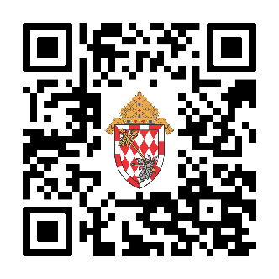
• How to avoid problems in your Will, Powers of Attorney, and Estate Trustee selection
• How to create your own Catholic legacy
• Catholic traditions around cremation, burials, and funerals
To register:
- Scan the QR code:

- Or visit qrco.de/WebSep26
- You may also register by email by contacting
Development@ArchToronto.org. Please write “Webinar September 26” in the subject line and include your name in the body of the message.

